**Welcome to**

We would like to thank you for choosing to join Kang Han Taekwondo. Kang Han is a member of British Taekwondo which is the national governing body for Taekwondo in the UK and is a member of World Taekwondo (WT).

Kang Han was established in 1992 and trains under the instruction of Grand Master Lennox (8th Dan).

Our club aims to teach people self-defence, increase fitness and flexibility, and to strengthen and condition the mind and body. Our club takes pride in building confidence in the young and old alike and being suitable for all ages, with our youngest members aged 3 and our oldest member over 60. Taekwondo is an Olympic sport, and it is recognised on a world platform.

In this pack there will be useful information regarding:

* Class prices
* Payments Options
* Licence and Memberships

(This needs to be completed and paid at reception after your / your child’s 2nd class)

If you need any further information, please ask at reception

Or email: **enquiries@kanghan.co.uk**

Telephone: **0115 963 2008**

Web: **Kanghantaekwondo.com**

**Class Prices and Payment Options**

**Individual Class Prices and Times**

|  |  |  |  |
| --- | --- | --- | --- |
| **DAY** | **TIME** | **CLASS TYPE** | **COST** |
| MONDAY | 5-6PM | Tigers Main session | £7 |
|  | 6-7PM | Juniors Main Session | £8 |
|  | 7-9PM | Juniors and Adults Main session | £8 |

|  |  |  |  |
| --- | --- | --- | --- |
| WEDNESDAY | 5-6PM | Tigers Main session | £7 |
|  | 6-7PM | Juniors Main Session | £8 |
|  | 7-9PM | Juniors and Adults Main session | £8 |

|  |  |  |  |
| --- | --- | --- | --- |
| FRIDAY | 5-6PM | Poomsae (patterns 1-5) | Under age 7 - £7  Aged 8+ - £8 |
|  | 6-7PM | Poomsae experienced | Under age 7 - £7  Aged 8+ - £8 |

|  |  |  |  |
| --- | --- | --- | --- |
| SATURDAY | 11-12PM | Tigers, Juniors & Adults Main Session | Aged under 7 - £7  Aged 8+ - £8 |
|  | 12-2PM | Sparring Training | Aged under 7 - £7  Aged 8+ - £8 |
|  | 12-2PM | Black Belt Training | Aged under 7 - £7  Aged 8+ - £8 |

EACH SESSION ATTENDED MUST BE SIGNED IN AND PAYED FOR AT RECEPTION

**Monthly Payment Prices**

PLEASE ENSURE ALL MONTHLY PAYMENTS ARE PAID BY THE 1ST OF EACH MONTH

|  |  |
| --- | --- |
| **AGE** | **MONTHLY PAYMENT** |
| 3-7 years (Tigers) | 1 session per week - £28 |
|  | 2 sessions per week - £52 |
|  | Unlimited sessions - £60 |

|  |  |
| --- | --- |
| 8+ years (Juniors and Adults) | 1 session per week - £30 |
|  | 2 sessions per week - £56 |
|  | Unlimited sessions - £70 |

|  |  |
| --- | --- |
| Family (3+ registered members) | 1 session per week - £65 |
|  | 2 sessions per week - £95 |
|  | Unlimited sessions - £135 |

WE TAKE BOTH CASH AND CARD PAYMENTS AS WELL AS BANK TRANSFER

**Bank details**

|  |  |  |  |
| --- | --- | --- | --- |
| **Branch** | **Account name** | **Sort code** | **Account number** |
| Eastwood | Kang Han Taekwondo Limited | 40-20-12 | 41853791 |

**Kang Han Tigers**

Our Tiger’s classes are tailored specifically for our youngest students aged 3-6 years. Alongside the Martial Arts training, these classes are great for teaching your child:

Personal discipline:

* Respecting others
* Sharing with other children
* Listening carefully to instructions
* Concentration and resisting distractions
* Awareness of the body and personal space

Physical discipline:

* Hand-eye coordination
* Increased flexibility
* Coordination and stamina
* Development of fundamental motor skills

Some other benefits of Taekwondo training include:

* Developing a sense of independence and personal accomplishment
* Developing a love for learning a new skill
* Increased confidence and self-esteem
* Building social relationships with other children

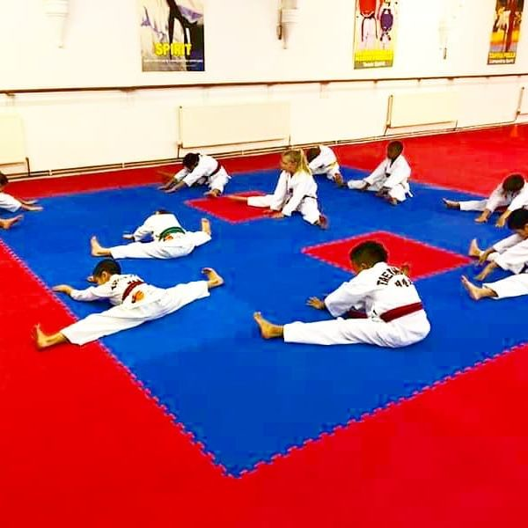

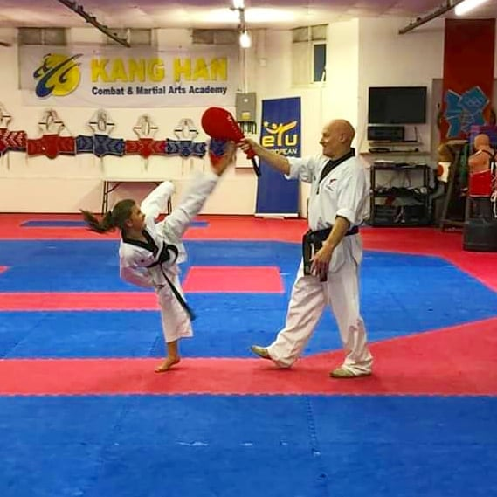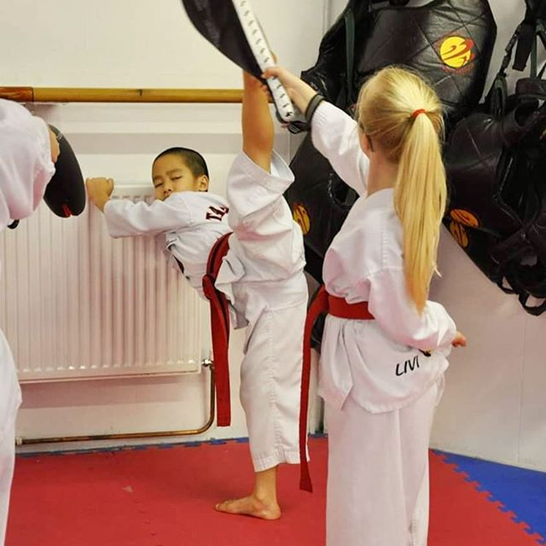

* 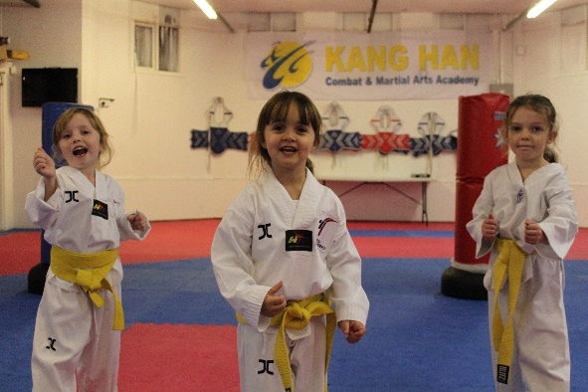

**Equipment**

Ask at reception if you wish to purchase any of the below items. Please note that although we typically keep White V Necks in stock, you may have to wait for other items to be ordered.

**Uniform (Dobok)**

|  |  |  |
| --- | --- | --- |
| **Item** | **Size** | **Price** |
| White V Neck | 110 & 120 cm | £40 |
|  | 130, 140 & 150cm | £42 |
|  | 160. 170, 180 & 190 cm | £52 |

|  |  |  |
| --- | --- | --- |
| Black V Neck | 110 & 120 cm | £40 |
|  | 130, 140 & 150 cm | £42 |
|  | 160, 170, 180 &190 cm | £52 |

**Sparring Kit**

|  |  |  |
| --- | --- | --- |
| **Item** | **Size** | **Price** |
| Head guard  (Available in blue, red, or white) | XS, S | £34 |
| M, L, XL | £35 |

|  |  |  |
| --- | --- | --- |
| Chest Protector(Body armour) with reversible red and blue sides | XS (1), S (2) | £35 |
| M (3), L(4), XL (5) | £40 |

|  |  |  |
| --- | --- | --- |
| Shin Protectors (Shin guards) | XXS. XS. S | £24 |
| M, L , XL | £27 |

|  |  |  |
| --- | --- | --- |
| Forearm Protectors (Arm guards) | XXS. XS. S | £24 |
| M, L , XL | £26 |

|  |  |  |
| --- | --- | --- |
| Hand Protectors (Gloves) | XXS. XS. S | £20 |
| M, L , XL | £24 |

|  |  |  |
| --- | --- | --- |
| Groin guard ( Male or female) | XXS. XS. S | £16 |
| M, L , XL | £18 |

|  |  |  |
| --- | --- | --- |
| Foot protectors | XXS. XS. S | £24 |
| M, L , XL | £27 |

|  |  |  |
| --- | --- | --- |
| Electronic Foot Protectors | XXS. XS. S | £38 |
| M, L , XL | £42 |

**Kang Han Club Clothing**

|  |  |  |
| --- | --- | --- |
| Item | Size | Price |
| Team Kang Han Tracksuit | CHILD- 5-6, 78, 9-11, 12-13 YRS | £50 |
| ADULT- S, M, L, XL, XXL |

|  |  |  |
| --- | --- | --- |
| Team Kang Han Tracksuit Top | CHILD- 5-6, 78, 9-11, 12-13 YRS | £25 |
| ADULT- S, M, L, XL, XXL |

|  |  |  |
| --- | --- | --- |
| Team Kang Han Tracksuit Bottoms | CHILD- 5-6, 78, 9-11, 12-13 YRS | £20 |
| ADULT- S, M, L, XL, XXL |

|  |  |  |
| --- | --- | --- |
| Team Kang Han Short Sleeve T-shirt | CHILD – S, M, L | £23 |
| ADULT- S, M, L, XL, XXL |

|  |  |  |
| --- | --- | --- |
| Team Kang Han Ladies T-Shirt | CHILD – S, M, L | £23 |
| ADULT- S, M, L, XL, XXL |

|  |  |  |
| --- | --- | --- |
| Team Kang Han Long Sleeve Sweatshirt | CHILD – S, M, L | £30 |
| ADULT- S, M, L, XL, XXL |

|  |  |  |
| --- | --- | --- |
| Team Kang Han Shorts | CHILD – S, M, L | £10 |
| ADULT- S, M, L, XL, XXL |

|  |  |  |
| --- | --- | --- |
| Team Kang Han Training Jacket | CHILD – S, M, L | £40 |
| ADULT- S, M, L, XL, XXL |

**Membership**

To apply for a Licence and Membership you must:

* Apply online at *https://www.british-taekwondo.com*
* Please sign up to the Hub on the British Taekwondo website and complete your online application
* Once completed, your application will be pending until you pay your Membership fee of £35 at reception
* Reception will then approve your application and pay for the Membership
* You will receive an email confirming that this has been done

If you have any queries regarding this process, please see reception

Or email: [**enquiries@kanghan.co.uk**](mailto:enquiries@kanghan.co.uk)

Telephone: **0115 963 2008**

Web: **Kanghantaekwondo.com**

**Tigers membership**

Request a Tigers licence form from reception

* Take the form away with you to complete
* Please return the form to reception, along with your Membership fee of £35
* Reception will then approve your application and pay for the Membership
* Reception will confirm that this has been done

**Code of Conduct for Parents**

Kang Han Taekwondo is fully committed to safeguarding and promoting the wellbeing of all its members.

The club believes that it is important that members, coaches, administrators, and parents associated with the club should always show respect and understanding for the safety and welfare of others. Parents are encouraged to always be open and honest and share any concerns or complaints that they may have about any aspect of the club with the Centre Manager.

**As a parent of a member of Kang Han Taekwondo, you are expected to abide by the following code of conduct:**

* Encourage your child to learn the rules so they train and compete within them
* Discourage unfair training and competing
* Do not argue with Officials or Coaches
* Help your child to take part in our sport
* Never force your child to train or compete
* Set a good example by recognising fair play and applauding good performance of all
* Never punish or belittle a child for losing or making mistakes
* Publicly accept officials’ judgements
* Support your child’s involvement and help them to enjoy our sport
* Always use the correct and proper language